Michaël Borremans presents paintings, video and three new canvases
at Galerie Rudolfinum

Michaël Borremans The Duck
22. 1. – 12. 4. 2020
Galerie Rudolfinum
Exhibition Curator: Petr Nedoma

With his innovative approach to painting, the Belgian artist Michaël Borremans (born 1963) has attained a position of distinction on the international scene. His canvases address universal themes that resonate with a specifically contemporary nuance and his oeuvre is characterised by a strong, unsettlingly psychological aspect. With thirty pieces on display, The Duck presents a cross-section of Borremans’ painting practice as well as video installations. For the very first time, the artist will also exhibit three of his latest paintings made in Autumn 2019 specifically for Galerie Rudolfinum.

“Michaël Borremans’ paintings present static scenes that in actual fact are an illusory reflection of the artist’s imagination. His way of grasping reality has much to do with the pictorial world of Dutch painting from the seventeenth and eighteenth centuries. Even though he often links his pictorial subjects with latently present violence, they stand out with
the extraordinary beauty of their execution,” notes the exhibition curator and Galerie Rudolfinum director Petr Nedoma.
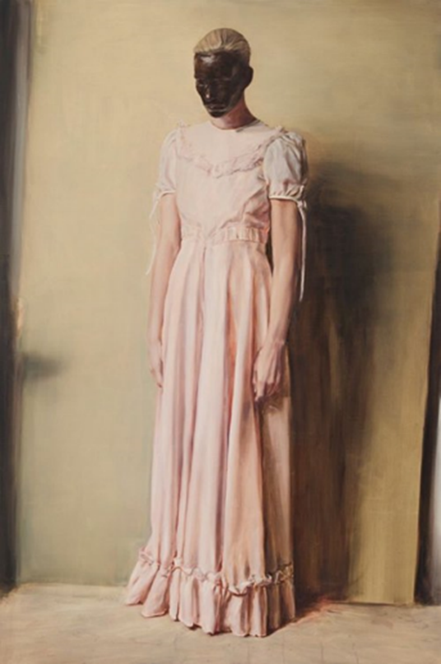
The specific illusive quality of Borremans’ paintings betrays
the artist’s interest in the mediums of film and photography. Scenes depicted in unnaturally slow motion, precise details and
the vibrant character of the paintings attest to an endeavour
to bring us closer to the transcendental dimension of spiritual questions, albeit with a lightly ironic tone.

Behind this lies the loss of a forgotten, long set aside innocence of the painted image, the refusal of the possibility of direct observation of reality and its reproduction through painting. Today, painting can no longer permanently move merely on the level of the documentation of reality. It always entails
a submersion into the long tradition of the imaginative world
of painting as such.

“Borremans is grounded in historically substantiated depiction,
it is one of the values with which he deliberately works, again and again he likes to bring to the surface an abundance of
the interpretational layers that have accumulated over the centuries. He has studied the old masters very intensively, and thanks to them he could later fully elaborate his exceptional painting talent,” adds Petr Nedoma.

Another essential hallmark of Borremans’ practice is
a detachment from the actuality of the everyday, a movement entirely outside of the endless flow of information that we feed on on a daily basis in a futile desire to capture something significant of life’s reality.

Almost imperceptible hints at touching zones that are taboo become a source of agitated excitations that our minds may interpret as a something slightly threatening or as being present in a forbidden zone. The static tension in Michaël Borremans’ motionless paintings of bizarre banalities is clearly the most effective force of attraction in his stratified painting universe.

CATALOGUE
Galerie Rudolfinum has published an eponymous catalogue to accompany Michaël Borremans’ exhibition The Duck containing an essay by the exhibition curator Petr Nedoma and a text by art historian Petr Vaňous. The publication includes reproductions of all the exhibited works. It was graphically designed by Petr Bosák and Robert Jansa (20YY Designers).

ARTPARK – Vrhám stín (I Cast a Shadow)
In conjunction with Michaël Borremans’ show The Duck, Galerie Rudolfinum’s relaxation and education centre Artpark has been given a new look. Czech artist Veronika Drahotová put together a site-specific project reflecting upon the exhibition with the title Vrhám stín (I Cast a Shadow). Artpark offers educational programmes for school groups, but also for the general public, including the much sought-after Sunday workshops for kids.

Entry to the exhibition is free of charge.

Photo Caption: Michaël Borremans, Angel, 2013, courtesy Zeno X Gallery, Antwerp. Photo: Peter Cox

For the latest information on Galerie Rudolfinum please visit:

www.galerierudolfinum.cz
@galerie.rudolfinum
@artpark.rudolfinum

Gallery Partner
Nadační fond Avast

Media Partners
RESPEKT, Forbes, Radio 1

Media Contact
Maja Ošťádalová, +420 602 44 10 10, ostadalova@rudolfinum.org

