Jiří Příhoda VOID

Galerie Rudolfinum
28 April – 28 August 2022
Curator: Petr Nedoma

(Prague, 27 April 2022) The Jiří Příhoda VOID exhibition, taking place at the Galerie Rudolfinum between
28 April and 28 August 2022, is the most extensive showcase of Jiří Příhoda’s practice to date with a deeply developed configuration of internal connections between its constituent installations – both on the level
of the interpenetration of their forms, and their conceptual sequence. The oeuvre of Jiří Příhoda, a Czech artist living in the US, stands out with its absolutely unwavering level of excellence, by far exceeding
the current standard of presentations of its type, making it almost one of a kind on the Czech art scene.

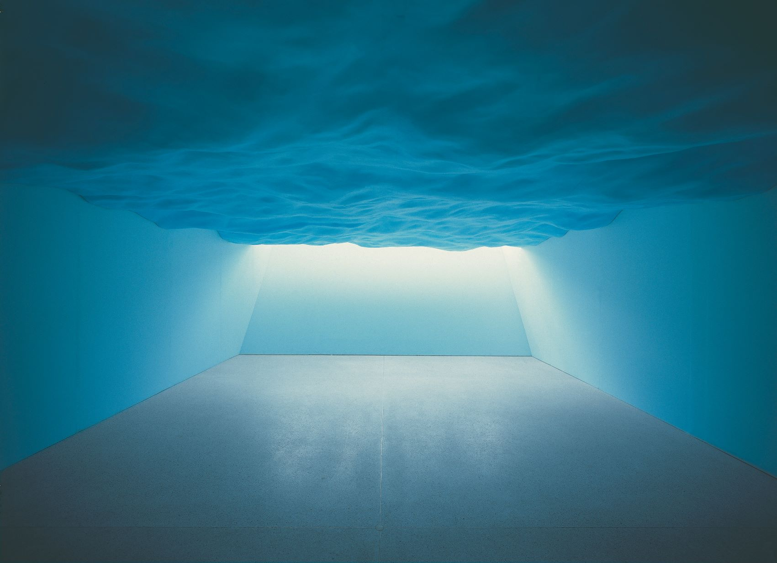

“The exploration of space, volume, matter and emptiness are the basic characteristics of Jiří Příhoda’s art.
Put into practice, his morphologically immensely inventive and innovative studies of imaginary objects become highly inspiring sites that interconnect architectural designs with fine art sculpture,” says Petr Nedoma,
the exhibition’s curator and director of Galerie Rudolfinum.
Jiří Příhoda employs architectural devices to deftly navigate abstract spatial studies that are best understood from the perspective of artistic solutions to material problems. The primary theme of his presentations of form-focused work, creativity and ingenuity is the search for emotionally balanced and at the same time inspiringly provocative designs of intersections of space and matter, as well as encounters between reality and mere
concept. All this is usually done without prior consideration for potential practical applications, although these are not ruled out. In other words, his theme also comprises the inspiration to highlight other than the utilitarian worlds that are inherently the focal point of architectural thinking, and he often does so in ways that are nonstandard or even downright ungraspable in practice.

Příhoda’s highly conceptual thinking regarding the abstract construction of matter does not lie far from meditative approaches to the architectural construction of inner and outer space, whose form is increasingly determined primarily through the reinterpretation of many traditional, profoundly considered and tried
and tested historical architecture practices that almost approach classical balance and reference the canons
of antiquity. The Rudolfinum’s complex and complicated neo-renaissance architecture provides an important and inspirational “counterpoint” for the artist – its qualities always stand out best when confronted with strong contemporary art concepts.

While developing the project it was necessary to consider a number of different options for dovetailing
the constructions designed by the artist in line with the technical possibilities of the building. The subsequent investigation of the different ways they could be executed resulted in Příhoda’s entire oeuvre being taken
to a new level of precision, if not, in fact, a synthesis. All of a sudden, many elements that had initially seemed
to be merely latent, unconnected steps emerged with a new clarity. The relationship between Příhoda’s works and a building permeated by an extremely rich structure of memory and historical references constitutes
a highly complex and involved dialogue between two distinctly formulated approaches. The thematization
of the building of the Rudolfinum through of the presentation of Jiří Příhoda’s practice primarily entails emphasising the formal, spatial and volumetric qualities of the solutions he has introduced.

Catalogue
Galerie Rudolfinum is publishing a catalogue to accompany the exhibition Jiří Příhoda VOID with an introductory text by Peter Nedoma, an essay by American art and architecture historian Christopher Long and the Czech art historian Filip Šenk. Numerous photographs from the installation of the exhibition are also included.
The exhibition’s graphic design was conceived by Petr Bosák and Robert Jansa (20YY Designers).

Photograph caption:
Take 02 "THE FLOOD", 1995-96
... life-size sculptural depiction of a negative imprint of a wavy sea surface...
polystyrene, wood, hardboard, plywood, w. 480 cm, h. 170>220 cm, l. 900 cm. Archive of Jiří Příhoda.

Admission to the exhibition Jiří Příhoda VOID is free thanks to the Abakus Foundation.
Photography permitted without flash. Share your photos @galerierudolfinum #VOID
For more information about the exhibition Jiří Příhoda VOID, please visit www.galerierudolfinum.cz.

Exhibition Partner: J&T BANKA
Gallery Partner: Abakus Foundation
Media Partners: Respekt, Forbes, Radio 1

Media Contact: Maja Ošťádalová, +420 602 44 10 10, ostadalova@rudolfinum.org

