Galerie Rudolfinum extends Compassion Fatigue Is Over exhibition
Visitors will get to see the exhibition, it will be open for at least two months from
the moment of the galleries´ reopening

Compassion Fatigue Is Over
21. 1. – 18. 4. 2021 - through summer 2021
Galerie Rudolfinum
Exhibition curators: Jen Kratochvil, Petr Nedoma
The exhibition Compassion Fatigue Is Over, which has been open online since 21 January, has not been able
to welcome the public for its entire duration, i.e. until Sunday 18 April 2021, due to the pandemic. The only way to see it has been online programme presented on social network platforms.

"We do not want visitors to miss out on the direct experience of the exhibition and we want them to have enough time and space to see it in person in the gallery. I am pleased that we were able to negotiate the extension of the exhibition Compassion Fatigue Is Over so that we can show it to the public for at least two months from the date the gallery re-opens in the spring. And, of course, for free, as is the tradition with us,“ comments Petr Nedoma, the director of Galerie Rudolfinum and one of the curators of the exhibition.
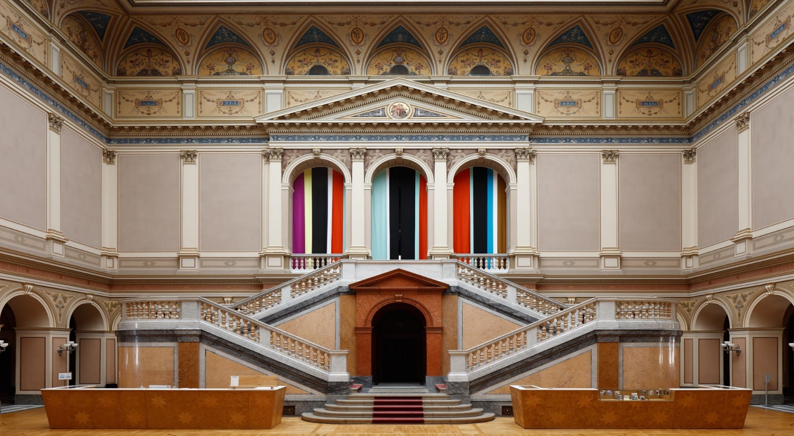

"As part of our broader programming line Rudolfinum_Time-Based, Compassion Fatigue is Over reflects on contemporary themes such as racial intolerance, labour exploitation, redrawing of historical narratives, sexuality, gender, fallen and rediscovered utopias, or abstract thinking as necessary conditions for any rational justice," explains Jen Kratochvil who curated the series of films and videos together with Petr Nedoma.

The key contemporary themes are reflected in the very title of the exhibition - Compassion Fatigue Is Over - which refers to a clinically defined mental state of "compassion fatigue" that afflicts the information-filled mind of today's people, who – on top of everything – have their heads full of questions related to the ongoing pandemic.

South African artist Candice Breitz participates in the exhibition with the series Sweat (2018), depicting
the testimonies of sex workers from Johannesburg, members of the eponymous activist organization campaigning for a change of legislation and equal rights of their profession (SWEAT - Sex Workers Education
and Advocacy Taskforce).

Slovak artist Anna Daučíková enters the exhibition with two films On Allomorphing (2017) and Thirty-three Situations (2015). Daučíková's work monitors with extraordinary sensitivity how dominant social and political systems shape individual identity and personal expression.

A specific role in the whole of the exhibition is played by the film Chimera (2019) by Haris Epaminonda, Cypriot artist living in Berlin. The film shown in a separate viewing theatre, acts as a catalyst within the exhibition
to start the process of absorbing individual works.

Another prominent name of world visual art, Naeem Mohaiemen, presents also two of his films. In the film Tripoli Cancelled (2017), he was freely inspired by the story of his father, who was forced to spend nine long days at Athens' Ellinikon Airport in 1977 after losing his passport. At the height of the refugee crisis, the airport became a temporary shelter for migrants awaiting permission of official entry into Europe. The starting point for the feature three-channel film Two Meetings and a Funeral (2017) is the search for a non-Euro-American perspective on the political solution of the bipolar conflict between the Western and Eastern worlds. For Two Meetings and a Funeral and his other similarly oriented works, Mohaiemen was nominated for the prestigious British Turner Prize.
The Canadian Jeremy Shaw set his video film I Can See Forever (2018) into a fictional future, where he develops the story of a young man who was part of a failed government experiment trying to merge man and machine, who now lives with "residual" 8.7% artificial DNA.

The films November (2004) and Lovely Andrea (2007) by the German artist Hito Steyerl, which we can perceive today as a classic in her ouvre, were created while she was still working in the medium of documentary film. In Lovely Andrea, the author visits Tokyo's photography studios specializing in traditional Japanese bondage to find a film she modelled for as a young film student in the mid-1980s. What the two films have in common is Andrea Wolf, a teenage friend of Steyerl, a political activist, a member of the PKK (Kurdish Workers' Party), a revolutionary organization active in the Turkish-Kurdish conflict.

The concept of the exhibition installation is framed by architectural interventions by Anetta Mona Chisa and Alexandra Vaid, together with coloured photograms by Vajd.
Compassion fatigue is far from over, as the name of the exhibition declares. We are still tired. Some deal with fatigue with indignation, others with meditation. Compassion Fatigue Is Over offers a temporary alternative solution. Possibility of peace and concentrated attention. This, however, does not mean that Galerie Rudolfinum is transformed into a cinema. Instead, it creates a seamless, circular narrative stringing the individual themes together with the help of a navigation system, carefully choreographing re-emerging elements of exhibition architecture.

Thanks to free admission, Compassion Fatigue Is Over invites visitors to return repeatedly, as the last thing
it wants to cause them is fatigue.

ONLINE EXHIBITION PROGRAMME
During the closure of the galleries due to government anti-epidemic regulations, join our online program
for the Compassion Fatigue Is Over exhibition on the Galerie Rudolfinum website and social platforms.
EXHIBITION GUIDE
More information on the featured artists and works can be found in the Guide to the Compassion Fatigue
Is Over, which is available on the Rudolfinum Gallery website. Visitors will be able to open it via a QR code when viewing the exhibition. It contains an introduction text by the curator and profiles of individual artists and their exhibited works. The graphic design is by Štěpán Marko, who is also the author of the graphic design
of the exhibition.
https://www.galerierudolfinum.cz/cs/vystavy/prave-probiha/compassion-fatigue-is-over/

Photo caption: Compassion Fatigue Is Over, a view of the installation © Galerie Rudolfinum, photographer Martin Polák

Light boxes for the exhibition Compassion Fatigue Is Over were made by Atlas Advertising Group.

Admission free.
To keep up with the news, follow Galerie Rudolfinum at:



www.galerierudolfinum.cz
Gallery partner: Abakus
Media partners: Respekt, Forbes, Radio 1
Media requests and enquiries please contact:
Maja Ošťádalová, +420 602 44 10 10, ostadalova@rudolfinum.org

